
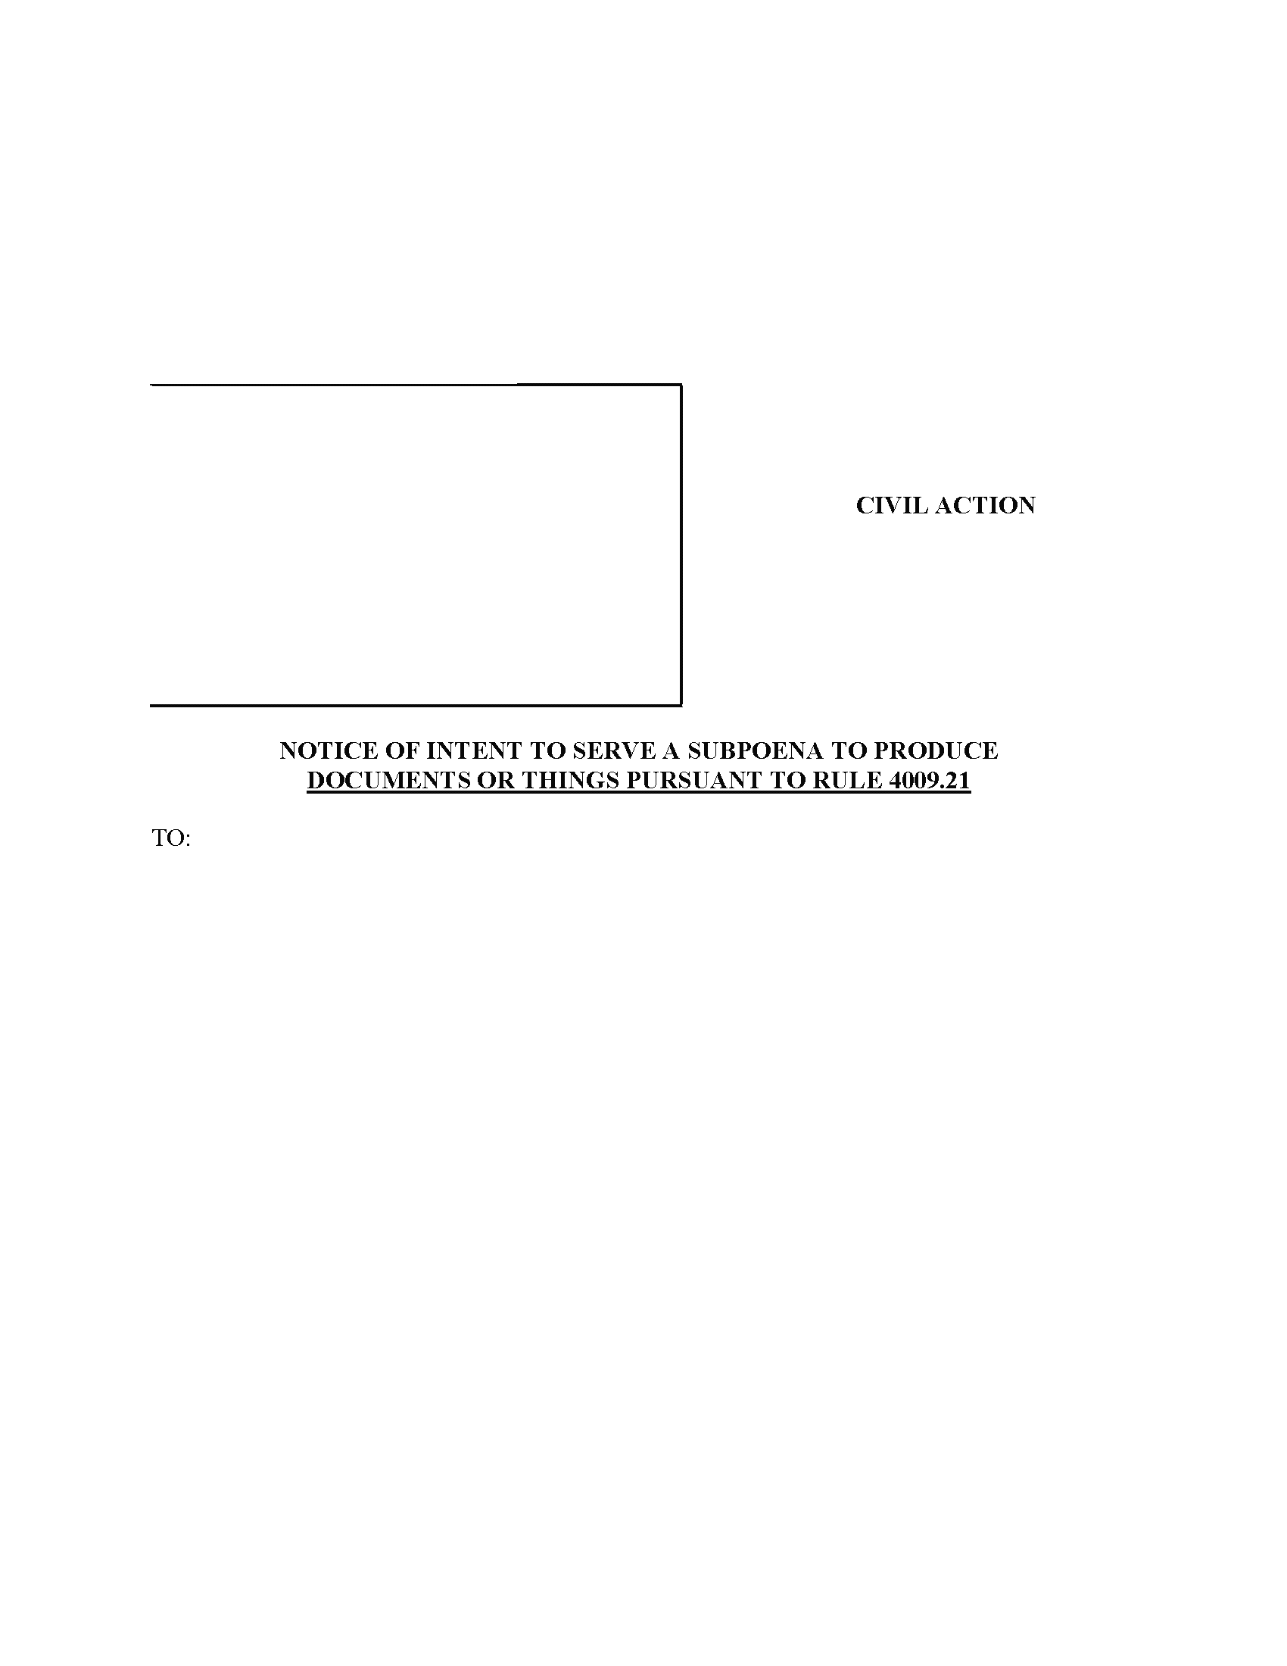
LUCAS AND CAVALIER LLC
By: Robert Cavalier, Esquire
Dan J. Colley, Esquire
Identification No: 65462, 178056
3700 Crestwood Parkway Suite 185
Duluth, GA 30096-____
PH: (678) 380-6655
Fax:(614) 542-6165
rcavalier@lucascavalier.com

Attorney(s) for Defendant(s)

Richard A Ingram Jr, Esquire
Richard A. Ingram, Jr. P.C.
631 Ronald Reagan Dr
Suite 102
Evans, GA 30809
Defendant(s) , intend(s) to serve record subpoena(s) identical to the Subpoena(s) attached to this notice on the following:
See Following PAGe
Order No. 01-30006
v.
COURT OF COMMON PLEAS
Richmond COUNTY

Term

No. 2009RCSC433

CIVIL ACTION
Douglas B Markle
Plaintiff(s)

Freddie Franklin Amerson Jr (UM)
Defendant(s)

_____________________________________________________________________________002 Wal-Mart, Inc. (Pharmacy Records) 702 Southwest 8th Street M.S. #0215, Bentonville, AR 72716-0215 (479) 204-6788 Fax : (479) 204-9655_____________________________________________________________________________
You have twenty (20) days from the date listed below in which to file of record and serve upon the undersigned an objection to the/these subpoena(s). If no objection is made, the subpoena(s) will be served.
Dan J. Colley, Esquire
Law Office of Dan J. Colley (House Counsel Grange Insurance Co)
3700 Crestwood Parkway
Suite 185
Duluth, GA 30096-____
Attorneys for defendant(s),

Order No. 01-30006
Dan J. Colley
Dan J. Colley
LUCAS AND CAVALIER. LLC
By:

Order No. 01-30006
I, Dan J. Colley,
Richard A Ingram Jr, Esquire
Richard A. Ingram, Jr. P.C.
631 Ronald Reagan Dr Suite 102
Evans, GA 30809
Attorney for Plaintiff(s)

Dan J. Colley
Dan J. Colley, Esquire
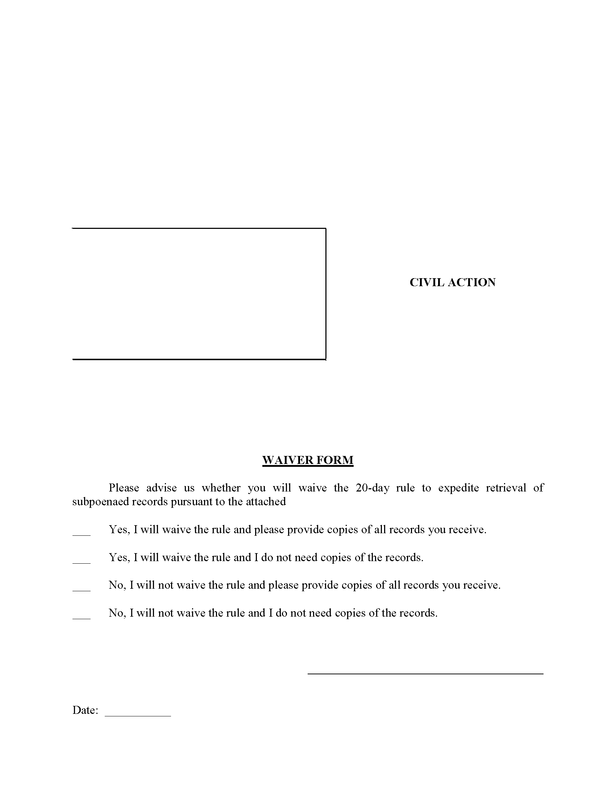
LUCAS AND CAVALIER LLC
By: Robert Cavalier, Esquire
Dan J. Colley, Esquire
Identification No: 65462, 178056
3700 Crestwood Parkway Suite 185
Duluth, GA 30096-____
PH: (678) 380-6655
Fax:(614) 542-6165
rcavalier@lucascavalier.com

Attorney(s) for Defendant(s)

Richard A Ingram Jr, Esquire

V.
COURT OF COMMON PLEAS
Richmond COUNTY

Term

No. 2009RCSC433

CIVIL ACTION
Douglas B Markle
Plaintiff(s)

Freddie Franklin Amerson Jr (UM)
Defendant(s)

Richard A Ingram Jr, Esquire
Richard A. Ingram, Jr. P.C.
631 Ronald Reagan Dr Suite 102
Evans, GA 30809
Attorney for Plaintiff(s)
Douglas B Markle
Dan J. Colley, Esquire
Dan J. Colley
I, Dan J. Colley,
Dan J. Colley, Esquire
Law Office of Dan J. Colley (House Counsel Grange Insurance Co)
3700 Crestwood Parkway Suite 185
Duluth, GA 30096-____
Attorneys for defendant,

Dan J. Colley

